PearlTech Software Solutions | 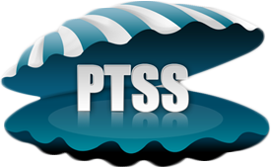

Sincerely,
Mosuru Narayana Rao,
Authorized Signatory
Pearltech Software Solutions.

